**How to convert searchable or selectable to non-searchable or non-selected in .NET PDF Document**

The Syncfusion Essential® PDF is a [**.NET PDF library**](https://www.syncfusion.com/document-processing/pdf-framework/net) used to create, read, and edit PDF documents. Using this library, you can convert searchable/selectable PDF documents to non-searchable/selected PDF documents using C#.

**Steps to convert searchable or selectable PDF document to non-searchable or non-selected PDF document programmatically**

1. Create a new console application project.A screenshot of a computer

   AI-generated content may be incorrect.
2. Install the [**Syncfusion.Pdf.Imaging.Net.Core**](https://www.nuget.org/packages/Syncfusion.Pdf.Imaging.Net.Core) and [**Syncfusion.PdfToImageConverter.Net**](https://www.nuget.org/packages?q=Syncfusion.PdfToImageConverter.Net) NuGet packages as a reference to your console application from [**Nuget.org**](https://www.nuget.org/).

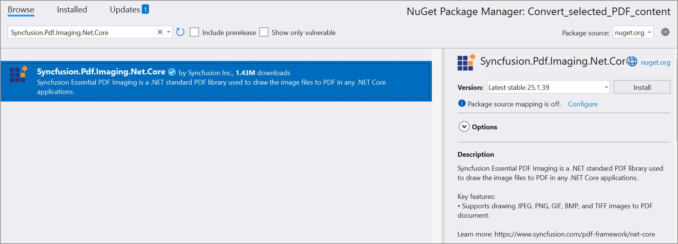

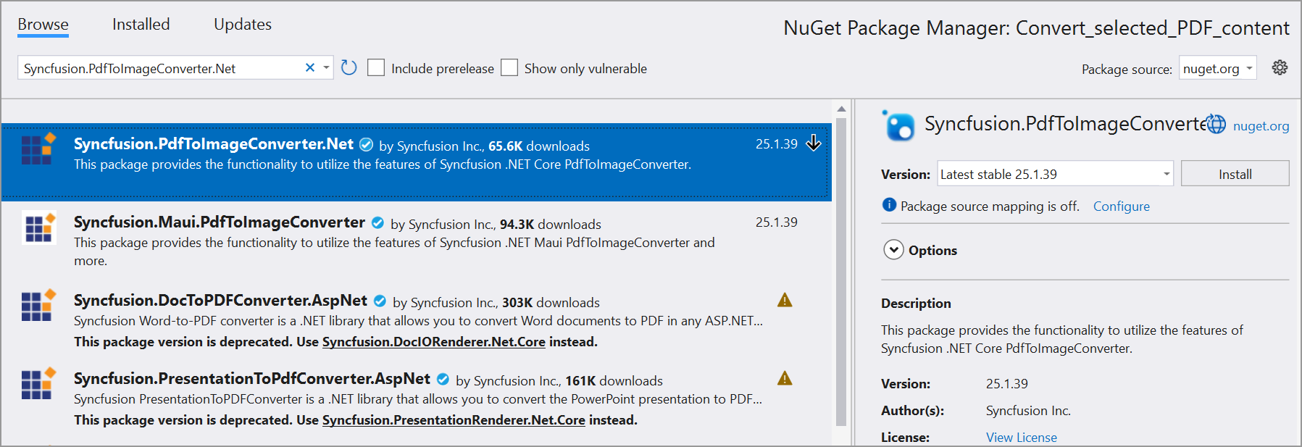

1. Include the following namespaces in the Program.cs file.

**C#**

using **Syncfusion**.Pdf.Graphics;

using **Syncfusion**.Pdf;

using **Syncfusion**.PdfToImageConverter;

1. Use the following code sample in Program.cs to convert searchable/selectable PDF documents to non-searchable/selected PDF documents.

**C#**

// Instantiate the PdfToImageConverter.

**PdfToImageConverter** imageConverter = **new** **PdfToImageConverter**();

// Load a PDF document as a stream.

**FileStream** inputStream = **new** **FileStream**(@"../../../Input.pdf", **FileMode**.Open, **FileAccess**.ReadWrite);

imageConverter.**Load**(inputStream);

// Convert PDF pages to images.

**Stream**[] outputStream = imageConverter.**Convert**(0, imageConverter.PageCount - 1, false, false);

// Create a new PDF document.

**PdfDocument** document = **new** **PdfDocument**();

// Loop through each item in the outputStream array.

**for** (int i = 0; i < outputStream.Length; i++)

{

// Create a PdfTiffImage object from the current outputStream item.

**PdfTiffImage** image = **new** **PdfTiffImage**(outputStream[i]);

// Add a new section to the document.

**PdfSection** section = document.Sections.**Add**();

// Set the size of the page in the section to match the physical dimensions of the image.

section.PageSettings.Size = image.PhysicalDimension;

// Set the margins of the page in the section to 0.

section.PageSettings.Margins.All = 0;

// Add a new page to the section.

**PdfPage** page = section.Pages.**Add**();

// Get the graphics context of the page

**PdfGraphics** graphics = page.Graphics;

// Draw the image on the page.

graphics.**DrawImage**(image, 0, 0, graphics.ClientSize.Width, graphics.ClientSize.Height);

}

// Save the document to a memory stream.

**MemoryStream** memoryStream = **new** **MemoryStream**();

document.**Save**(memoryStream);

// Write the content of the memory stream to an output PDF file.

**File**.**WriteAllBytes**("Output.pdf", memoryStream.**ToArray**());

// Close the document.

document.**Close**(true);

A complete working sample can be downloaded from [**Convert_PDF_content.zip**](https://support.syncfusion.com/agent/).

By executing the program, you will get ta PDF document as follows.

Take a moment to peruse the documentation for [**working with pages**](https://help.syncfusion.com/file-formats/pdf/working-with-pages). You can find options like inserting, rotating, importing, and rearranging the pages from an existing document, removing the pages, and splitting a PDF file into individual pages.

Refer to [**here**](https://www.syncfusion.com/document-processing/pdf-framework/net) to explore a rich set of Syncfusion Essential® PDF features.